Automatic Number Plate Recognition System`

DSP SELF STUDY

PROJECT BY

Prem Kumar D

Lakshmi Narayana B S

R D Amogh

Kishan Kumar

###### Introduction

The Automatic number plate recognition (ANPR) is a mass surveillance method

that uses optical character recognition on images to read the license plates on vehicles.

They can use existing closed-circuit television or road-rule enforcement cameras, or

ones specifically designed for the task. They are used by various police forces and

as a method of electronic toll collection on pay-per-use roads and monitoring traffic

activity, such as red light adherence in an intersection.

ANPR can be used to store the images captured by the cameras as well as the text

from the license plate, with some configurable to store a photograph of the driver.

Systems commonly use infrared lighting to allow the camera to take the picture at any

time of the day. A powerful flash is included in at least one version of the intersectionmonitoring

cameras, serving both to illuminate the picture and to make the offender

aware of his or her mistake. ANPR technology tends to be region-specific, owing to

plate variation from place to place.

The process of automatic number plate recognition consists of four

main stages:

(1) Preprocessing

(2) License plate localization

(3) Character segmentation

(4) Character recognition

* Preprocessing. As mentioned before, the system of automatic number plate

recognition faces many challenges. So, this step is essential to enhance the input

image and making it more suitable for the next processing steps. The first step done

in the preprocessing is to apply minimum filter to the image in order to enhance the

dark values in the image by increasing their area. This is mainly done to make the

characters and the plate edges bold, and to remove the effect of the light diagonal

strips that appear in the characters and edges of the Egyptian license plates .

*License Plate Localization. In this stage, the location of the license plate

is identified and the output of this stage will be a sub-image that contains only the

license plate.

\**Determining the exact location of the license plate.* Using the sub-image from

the last step which contains the license plate with some extra parts (if any), the

following processing is applied to this sub-image. The license plate may be skewed

because of the angle of the camera while image acquisition process.

\***Character Segmentation.** This stage is meant for segmentation of the characters

from the plate.

\***Character recognition.** The goal of this stage is to recognize and classify the

binary images that contain characters received from the previous one. After this stage

every character must have a label and an error factor, and this error factor if greater

than a predefined value will be used to reject false characters accidently passed from

the previous steps. For the sake of classification, some features must be collected

from the characters. The feature we work with in this system is the chain code of

the contour of the image after dividing it into four tracks then into four sectors

**BLOCK DIAGRAM**

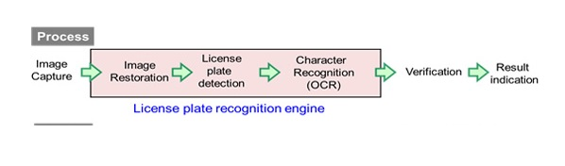

**Conclusion**

The objective of this paper was to study and resolve algorithmic and mathematical

aspects of the automatic number plate recognition systems, such as problematic of

machine vision, pattern recognition, OCR and neural networks. The problematic has

been divided into several chapters, according to a logical sequence of the individual

recognition steps. Even though there is a strong succession of algorithms applied

during the recognition process, chapters can be studied independently.

ANPR solution has been tested on static snapshots of vehicles, which has been

divided into several sets according to difficultness. Sets of blurry and skewed snapshots

give worse recognition rates than a set of snapshots which has been captured

clearly. The objective of the tests was not to find a one hundred percent recognizable

set of snapshots, but to test the invariance of the algorithms on random snapshots

systematically classified to the sets according to their properties.